
TABSAN EDUSPHERE
Mobile App Connection Guide
Connecting the EduSphere app to your web portal — set-up, accounts, sign-in and daily use
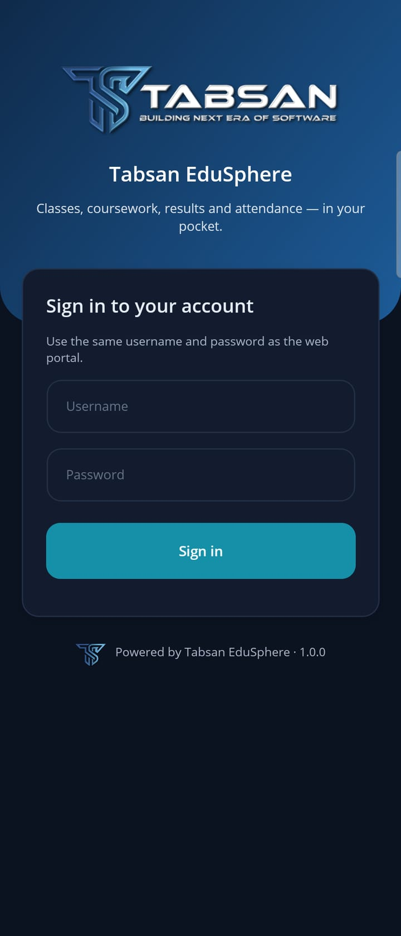 |   EduSphere  for Android and iOS | 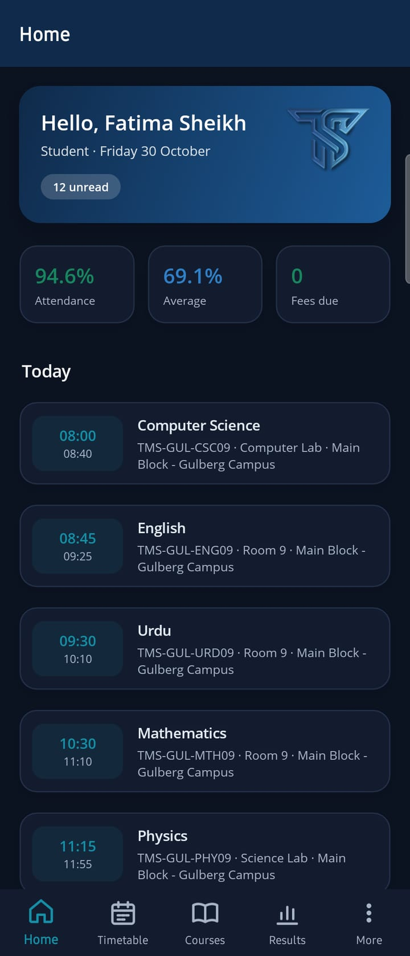
Version 1.0 · 30 October 2026
Tabsan Nexora — Building the Next Era of Software

About This Guide
This guide explains how the Tabsan EduSphere mobile app connects to the EduSphere web portal, and walks through everything needed to put the app in the hands of students, teachers and parents: preparing the server, building and distributing the app, preparing accounts in the portal, signing in, and using the app day to day.
Every app screenshot in this guide was taken from the Android app package (APK) running on a Samsung Galaxy Z Fold5 (cover screen, Android 16, dark mode), connected to an EduSphere test server with the School demonstration data (Tabsan Model School, Gulberg Campus). Portal screenshots come from the same server at the same time, so the app and the portal show the same records. In light mode the app shows white cards on a light grey background; everything else is the same.
Item | Detail
Product | Tabsan EduSphere mobile app (Android and iOS) and Campus Portal
Document | Mobile App Connection Guide
Version | 1.0 — 30 October 2026
App version | 1.0.0 (Tabsan branding)
Audience | IT administrators (chapters 2–3), portal administrators (chapter 4), students, teachers and parents (chapters 5–8)
Related documents | Tabsan EduSphere User Manual · SSO Setup Guide · mobile/README.md (developers)
Publisher | Tabsan Nexora

NOTE Your institution's app may carry its own name, logo and colour (a white-label build, chapter 3). The screens, menus and steps are the same.

Contents
About This Guide 1
Contents 2
1 How the App Connects to the Portal 4
1.1 One server, two ways in 4
1.2 What connects to what 4
1.3 Who does what 5
1.4 Checklist 5
2 Prepare the Server 6
2.1 Requirements 6
2.2 The Mobile settings on the API 6
2.3 The matching setting on the portal 7
2.4 Check the connection 7
3 Build and Distribute the App 9
3.1 What a build contains 9
3.2 Build for your institution 9
3.3 Logo, icon and splash screen 10
3.4 Distribute the app 10
3.5 Updates and versions 11
3.6 Test before going live 11
4 Prepare the Portal 12
4.1 Institution name on the app 12
4.2 Students and teachers 12
4.3 Create parent accounts 13
4.4 Link parents to their children 15
4.5 Single sign-on (optional) 16
4.6 Push notifications (optional) 17
5 Install the App and Sign In 18
5.1 Install 18
5.2 Sign in 18
5.3 If the app asks for an authenticator code 19
5.4 First sign-in with a temporary password 19
5.5 Sign in with your institution's account (SSO) 20
5.6 Language, server and signing out 20
6 Using the App — Students 22
6.1 Home 22
6.2 Timetable 23
6.3 Courses and course pages 23
6.4 Hand in an assignment 24
6.5 Results and attendance 25
6.6 Notifications 26
7 Using the App — Teachers 28
7.1 Home 28
7.2 Take attendance 28
7.3 Grade submissions 29
7.4 Post an announcement 30
8 Using the App — Parents 32
8.1 Home 32
8.2 A child's page 32
9 How the App and the Portal Stay in Step 34
9.1 Where each action shows 34
9.2 Example: an announcement from the app 34
10 Troubleshooting 36
10.1 Messages and what to do 36
10.2 Other problems 36
Appendix A Settings Reference 38
Appendix B API Endpoints Used by the App 39
Appendix C Glossary 40

1 How the App Connects to the Portal
The mobile app is not a separate system. It is a second way into the same EduSphere server that runs your web portal. Understanding this makes every later step obvious: the app needs to know the server's address, and users sign in with the accounts they already have.

1.1 One server, two ways in
The web portal and the mobile app both talk to the EduSphere API on your server. The API reads and writes one database. When a teacher takes attendance in the app, the portal shows it at once; when an administrator publishes results in the portal, students see them in the app the next time the screen refreshes. Nothing is copied or synchronised between the two, so they can never disagree.
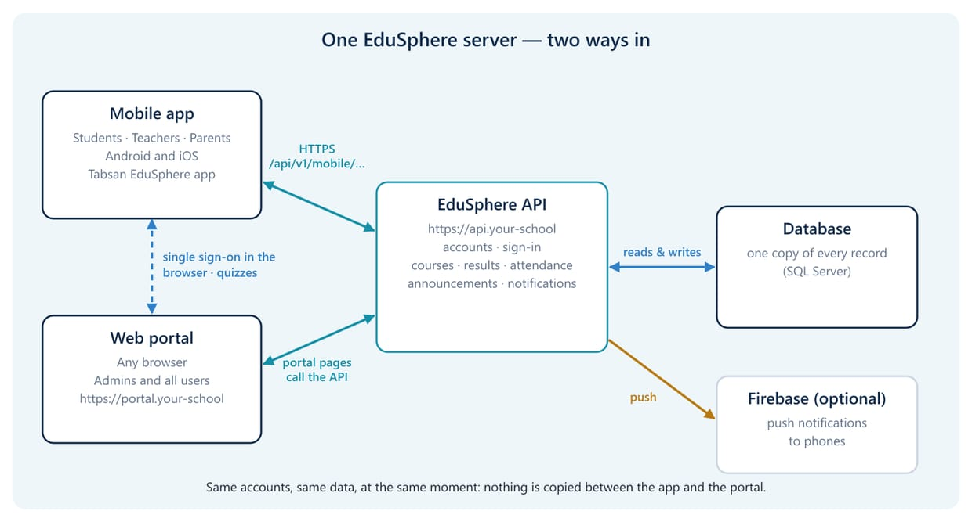
Figure 1.1 The portal and the app use the same API, database and accounts

What the phone keeps
- The sign-in session (an access token and a refresh token) in the phone's secure storage (Android Keystore, iOS Keychain), so users stay signed in until they sign out.
- The chosen language, and work that has not been sent yet (for example an unfinished answer on the hand-in screen while it is open).
- No copies of results, attendance or other records. Every screen is loaded from the server when it opens and when the user pulls down to refresh.

1.2 What connects to what
Connection | How | Set up in
App → API | HTTPS calls to https://<your API>/api/v1/... (sign-in, home, timetable, courses, results, notifications …) | The app build (API address), chapter 3
App → portal | The phone's browser opens the portal for single sign-on and for quizzes (exam settings and timing stay in the portal) | API setting Mobile:PortalBaseUrl, chapter 2
Portal → app | After single sign-on the portal hands a one-time code back to the app through its address scheme (edusphere://sso) | Mobile:AppRedirectUri on the API and the portal, chapter 2
API → phones | Push notifications through Firebase Cloud Messaging (optional) | Firebase project, app build and API, section 4.6
Portal → app branding | The institution name and subtitle from the portal's Dashboard Settings appear on the app's sign-in screen | Portal, section 4.1

1.3 Who does what
Role | Tasks | Chapter
IT administrator | Publishes the API over HTTPS, sets the Mobile settings, builds the app with the API address, publishes it to the stores or shares the APK, optionally sets up push notifications | 2, 3, 4.6
Portal administrator | Sets the institution name, creates parent accounts, links parents to their children, optionally sets up single sign-on | 4
Students, teachers, parents | Install the app and sign in with their portal account | 5–8

1.4 Checklist
Work through these steps in order. Each one names the section that explains it.
- The API is reachable from the internet over HTTPS with a trusted certificate (section 2.1).
- The Mobile settings are filled in on the API, and the portal uses the same return address (sections 2.2–2.3).
- https://<your API>/api/v1/mobile/config opens in a browser and shows your institution name (section 2.4).
- The app is built with your API address and published, or the APK is shared for a pilot (chapter 3).
- The institution name and subtitle are right in the portal (section 4.1).
- Parent accounts are created and linked to their children, if parents will use the app (sections 4.3–4.4).
- A student, a teacher and a parent sign in on a phone and see their own data (chapter 5).

2 Prepare the Server
The app talks only to the EduSphere API. This chapter makes sure phones can reach it securely and tells the API how the app signs in and where the portal is.

2.1 Requirements
Who does this: IT administrator
- The API must be reachable from phones on mobile data and on any Wi-Fi, by a public name such as https://api.your-school.edu.pk. Addresses like localhost or a private IP address only work inside your network.
- It must use HTTPS with a certificate trusted by phones (for example from Let's Encrypt or your certificate provider). Store builds of the app refuse plain http:// addresses and untrusted certificates.
- The portal must also be reachable from phones if you use single sign-on or quizzes, because the app opens it in the phone's browser.
- The server clock must be correct: sign-in tokens and single sign-on codes expire after a short time.
IMPORTANT Do not open the API to the internet over plain HTTP. Passwords and tokens would travel unencrypted. Test builds may use HTTP on a private network only (section 3.6).

2.2 The Mobile settings on the API
Who does this: IT administrator
Open appsettings.json (or appsettings.Production.json) of the API and fill in the Mobile section. Restart the API after saving.
"Mobile": {
"MinimumVersion": "1.0.0",
"LatestVersion": "1.0.0",
"AndroidStoreUrl": "https://play.google.com/store/apps/details?id=pk.edu.yourschool.app",
"IosStoreUrl": "https://apps.apple.com/app/id0000000000",
"PortalBaseUrl": "https://portal.your-school.edu.pk",
"AppRedirectUri": "edusphere://sso",
"HandoffSeconds": 120,
"MaxConsecutiveFailures": 5,
"Fcm": { "Enabled": false, "ProjectId": null, "ServiceAccountFile": null }
}

Setting | What it does | Typical value
MinimumVersion | Oldest app version allowed to sign in. Older apps show "This version of the app is no longer supported. Please update it." with an Update button. | The version all users have
LatestVersion | Newest published version. Older apps show "A new version of the app is available." | Your latest store version
AndroidStoreUrl, IosStoreUrl | Where the Update button sends users. | Your store listings
PortalBaseUrl | The portal address the app opens for single sign-on and for quizzes. | https://portal.…
AppRedirectUri | Where the portal returns the one-time sign-in code after single sign-on. Must match the app's address scheme (section 3.2). | edusphere://sso
HandoffSeconds | How long that one-time code stays valid (30–600 seconds). | 120
MaxConsecutiveFailures | Failed push deliveries in a row after which a phone stops receiving push. | 5
Fcm | Push notifications through Firebase (section 4.6). | Disabled until set up

2.3 The matching setting on the portal
Who does this: IT administrator
The portal finishes single sign-on for the app, so it needs the same return address. In the portal's appsettings.json:
"EduApi": { "BaseUrl": "https://api.your-school.edu.pk" },
"Mobile": { "AppRedirectUri": "edusphere://sso" }

IMPORTANT If AppRedirectUri differs between the API, the portal and the app build, single sign-on ends in the browser instead of returning to the app. Password sign-in is not affected.

2.4 Check the connection
Who does this: IT administrator
The app reads its settings from the API before anyone signs in. Open this address in any browser, on a phone if possible, using mobile data rather than the school Wi-Fi:
https://api.your-school.edu.pk/api/v1/mobile/config

You should see your institution's settings. If the page does not open, phones cannot reach the API: check the DNS name, the firewall and the certificate before going further.
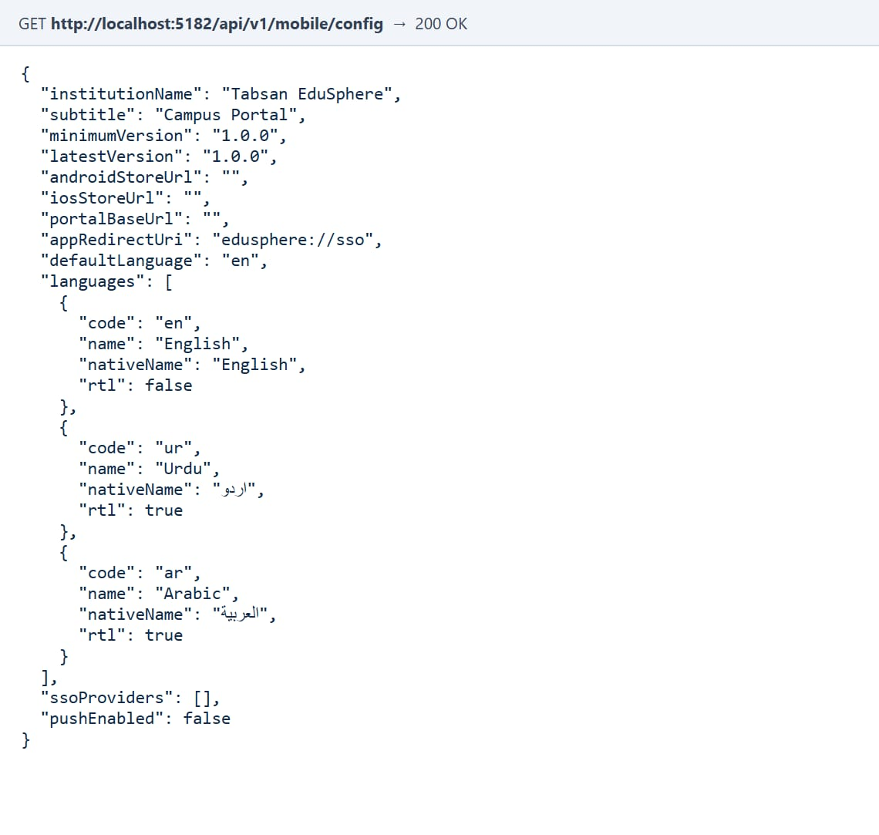
Figure 2.1 The configuration the app reads (from the test server used for this guide)
Field | Comes from
institutionName, subtitle | Portal › Dashboard Settings › Portal Branding (section 4.1). Shown on the app's sign-in screen.
minimumVersion, latestVersion, store URLs | The Mobile settings (section 2.2).
portalBaseUrl, appRedirectUri | The Mobile settings. On the test server portalBaseUrl is empty; on your server it must be the portal address.
languages, defaultLanguage | The portal's languages: English, Urdu and Arabic.
ssoProviders | Single sign-on set up in the portal (section 4.5). Each provider becomes a button on the sign-in screen.
pushEnabled | true when Firebase is set up on the API (section 4.6).

3 Build and Distribute the App
The API address is built into the app, so users never have to type a server address. Each institution gets its own build with its name, address and, if wanted, its own logo and colour.

3.1 What a build contains
Who does this: IT administrator
Property | Meaning | Default
App name | Name under the icon and in the stores. | EduSphere
App id | Unique store id, for example pk.edu.yourschool.app. Never change it after the first release. | com.tabsan.edusphere
API address | The HTTPS address of your API (chapter 2). The app connects only to this server. | —
Colour | Title bar, banners, icon background and splash screen. | #0F2A4A (Tabsan navy)
Scheme | The address scheme for the single sign-on return (<scheme>://sso). | edusphere
Version, build | Version shown to users (1.2.0) and a build number that grows with every store upload. | —
Logo | App icon, splash screen and the logo on the sign-in screen. | Tabsan logo

3.2 Build for your institution
Who does this: IT administrator (on the build computer: .NET 9 SDK with the MAUI workload, Android SDK, JDK 17; a Mac with Xcode for iOS)
Run the white-label build script from the mobile folder of the EduSphere source:
./build-whitelabel.ps1 -AppName "Tabsan Model School" -AppId pk.edu.tms.app `
-ApiBaseUrl https://api.your-school.edu.pk -Scheme edusphere `
-Version 1.0.0 -Build 1 -KeyStore ./tms/upload.keystore -KeyAlias upload

Parameter | Required | Notes
-AppName | Yes | Name under the icon.
-AppId | Yes | Store id (reverse domain name).
-ApiBaseUrl | Yes | Must start with https://.
-Color | No | Hex colour, for example #7A1F2B. Default Tabsan navy.
-Scheme | No | Lower-case letters; must match Mobile:AppRedirectUri on the API and portal (<scheme>://sso).
-Version, -Build | Yes | For example 1.2.0 and 12.
-Platform | No | android (default) or ios (on a Mac).
-GoogleServicesJson, -GoogleServiceInfoPlist | No | Firebase files for push notifications (section 4.6). Without them the app works without push.
-KeyStore, -KeyAlias | For Google Play | Upload key. Passwords are read from the EDUSPHERE_KEYSTORE_PASS and EDUSPHERE_KEY_PASS environment variables, never typed on the command line.
-Apk | No | Produce an installable .apk instead of a Google Play bundle (.aab).

The result is written to mobile/artifacts/<AppId>/<Version>-<Build>/.

3.3 Logo, icon and splash screen
Who does this: IT administrator
The standard build carries the Tabsan logo: the TS emblem as the app icon on a navy background, the emblem on the splash screen, and the full Tabsan logo at the top of the sign-in screen. To use your institution's artwork, replace these files before building and keep their names:
File (under mobile/Tabsan.EduSphere.Mobile/Resources) | Used for
AppIcon/appicon.svg | Icon background
AppIcon/appiconfg.png | Icon foreground: the emblem, inside the middle two thirds of a transparent square
Splash/splash.png | Splash screen emblem (shown on the brand colour)
Images/tabsan_wordmark.png | Logo at the top of the sign-in screen (light artwork for a dark background)
Images/tabsan_mark.png | Emblem on the banners, the start screen and in Settings

3.4 Distribute the app
Who does this: IT administrator
- Google Play: upload the .aab to your Google Play Console listing. Publish it to an internal testing track first, then to production.
- Apple App Store: upload the .ipa from the Mac with Xcode or Transporter, test it with TestFlight, then submit it for review.
- Pilot without a store: build with -Apk and share the file through your institution's own channels. On Android, users allow "Install unknown apps" for the app they open the file with.
- After publishing, put the store links into AndroidStoreUrl and IosStoreUrl (section 2.2) so the Update button works.
TIP Raise MinimumVersion only after the new version is available in both stores; otherwise users are asked to update to a version they cannot get yet.

3.5 Updates and versions
Who does this: IT administrator
Change | Do this | Users see
New app version published | Raise LatestVersion | "A new version of the app is available." with an Update button
Old versions must stop working | Raise MinimumVersion | "This version of the app is no longer supported. Please update it."
Server address changes | New build with the new -ApiBaseUrl | Users install the update; their sign-in starts again

3.6 Test before going live
Who does this: IT administrator or developer
For testing, a debug build can use a test server over plain HTTP on your own network. This is how the screenshots in this guide were made: the APK was installed on an Android phone connected to the build computer, and the phone reached the test API through the debugging connection.
dotnet build Tabsan.EduSphere.Mobile/Tabsan.EduSphere.Mobile.csproj -c Debug -p:MobileTargets=net9.0-android `
-p:RuntimeIdentifier=android-arm64 -p:EmbedAssembliesIntoApk=true -p:AndroidPackageFormat=apk `
-p:ApiBaseUrl=http://localhost:5182
adb reverse tcp:5182 tcp:5182 # the phone's localhost:5182 is the build computer's API
adb install -r bin/Debug/net9.0-android/android-arm64/com.tabsan.edusphere-Signed.apk

WARNING Debug builds accept HTTP and are signed with a debug key. Never give them to users; use the white-label build (section 3.2) for anything real.

4 Prepare the Portal
Students and teachers already have everything they need: the app uses their portal accounts. This chapter covers the institution name the app shows, parent accounts, and the optional single sign-on and push notifications.

4.1 Institution name on the app
Who does this: SuperAdmin or Admin in the portal
The sign-in screen of the app shows the name and subtitle from the portal's branding, so users can see they are connecting to the right institution.
- Sign in to the portal and open Dashboard Settings (in the Settings Related group of the menu).
- Under Portal Branding, enter the University / Institution Name and the Portal Subtitle.
- Select Save. The app shows the new name the next time its sign-in screen opens.

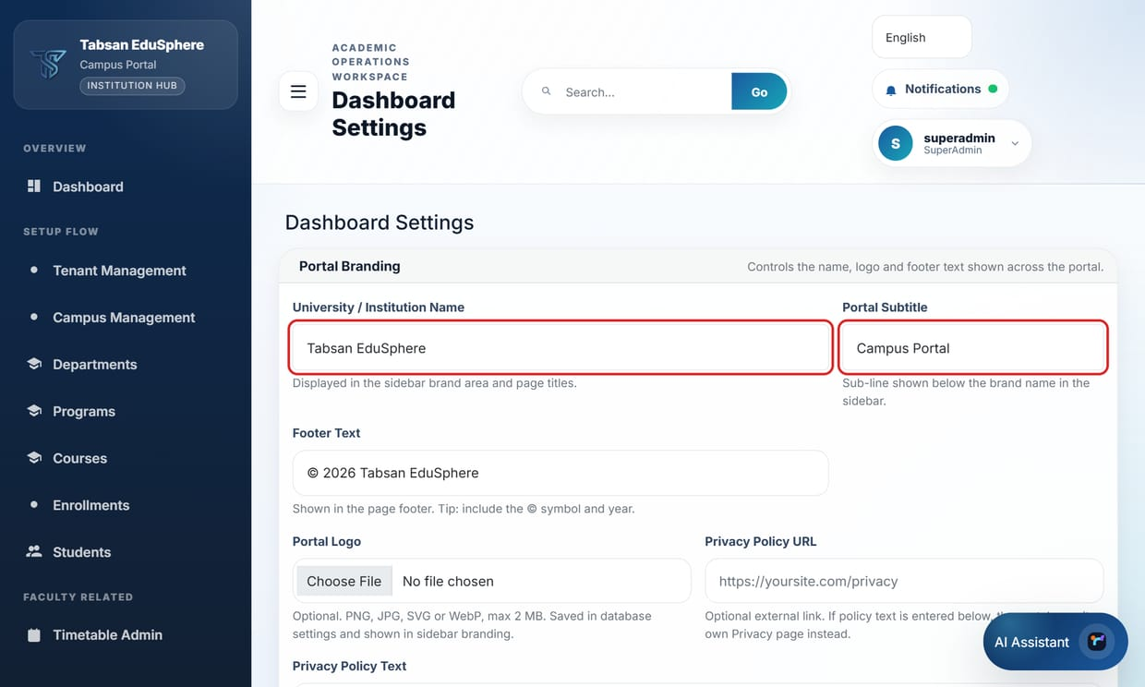
Figure 4.1 Portal › Dashboard Settings: the name and subtitle the app shows (outlined)

4.2 Students and teachers
Who does this: No action needed
Students and teachers sign in to the app with the same username and password as the portal. There is nothing to create or enable.
- A password changed in the portal applies in the app straight away, and the other way round.
- An account that is locked or deactivated in the portal cannot sign in to the app either.
- If two-factor authentication is switched on for an account, the app asks for the authenticator code too.
- Students see the courses they are enrolled in and teachers the courses they teach, exactly as in the portal.
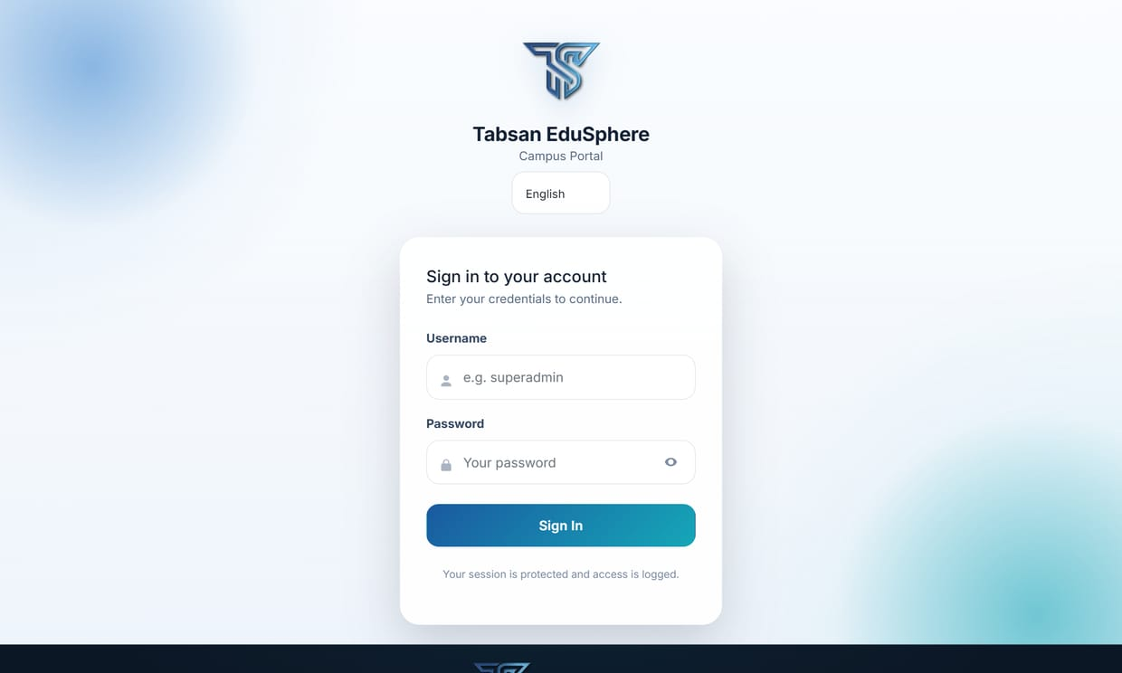
Figure 4.2 The portal's sign-in page: the same username and password open the app (compare Figure 5.1)

4.3 Create parent accounts
Who does this: SuperAdmin or Admin in the portal
Parents use the app to follow their children's results, attendance, fees and announcements. Parent accounts are for School students and have the role Parent.
- In the portal, open User Import.
- For one parent, use Create Single User: enter the Username, Email and Full Name, and choose the role Parent. Select Create User.
- For many parents, upload a CSV file under Import Users From CSV with Parent in the Role column.
- Give each parent their username. Their first password is the username itself; the app asks them to choose their own password at the first sign-in (section 5.4).

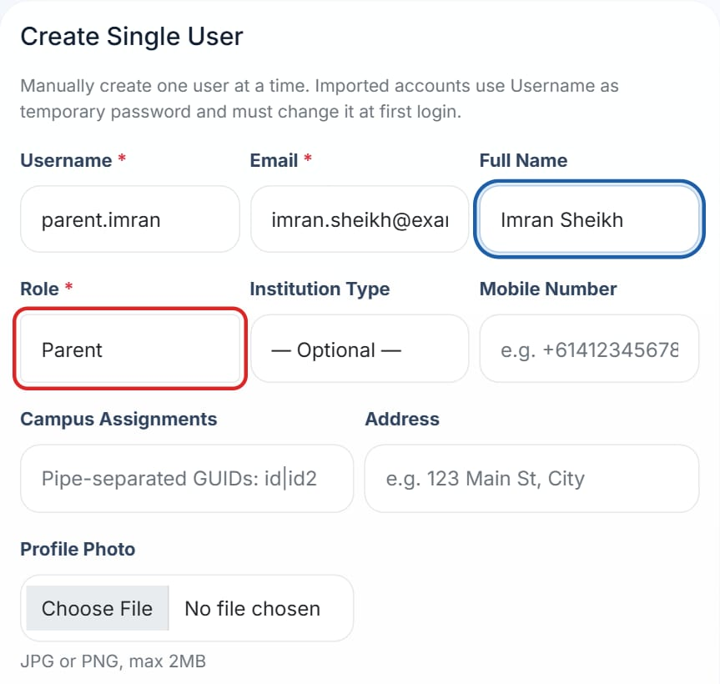
Figure 4.3 Creating a parent account (role Parent outlined)
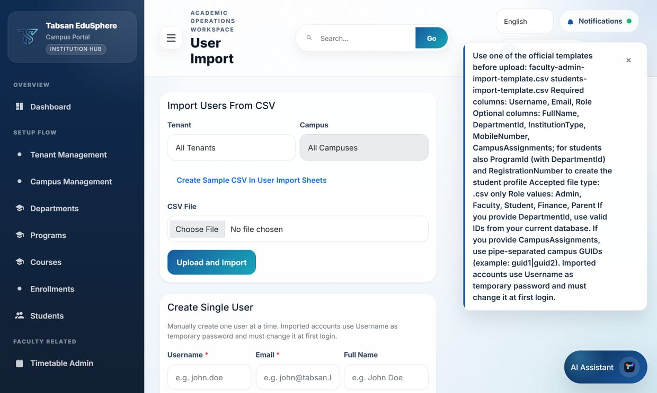
Figure 4.4 User Import, with the page tip listing the role values and the temporary password rule

4.4 Link parents to their children
Who does this: SuperAdmin or Admin in the portal
A parent sees only the children linked to their account. Links are made on the portal's Parent Links screen. One parent can have several children, and a child can have several parents (for example the father and the mother, each with their own account).
- In the portal, open Parent Links (in the Settings Related group of the menu, next to User Import).
- Under 1. Find the parent, type part of the parent's username, name, email or phone and select Search. Select the parent in the list; the number beside each name is how many children are linked already.
- Under 2. Link a student, search by the student's registration number or name (for example TMS-GUL-09-01 or Fatima).
- In the student's row, choose the Relationship (Father, Mother, Guardian, Grandparent, Sibling or Other) and select Link. Repeat for each child.

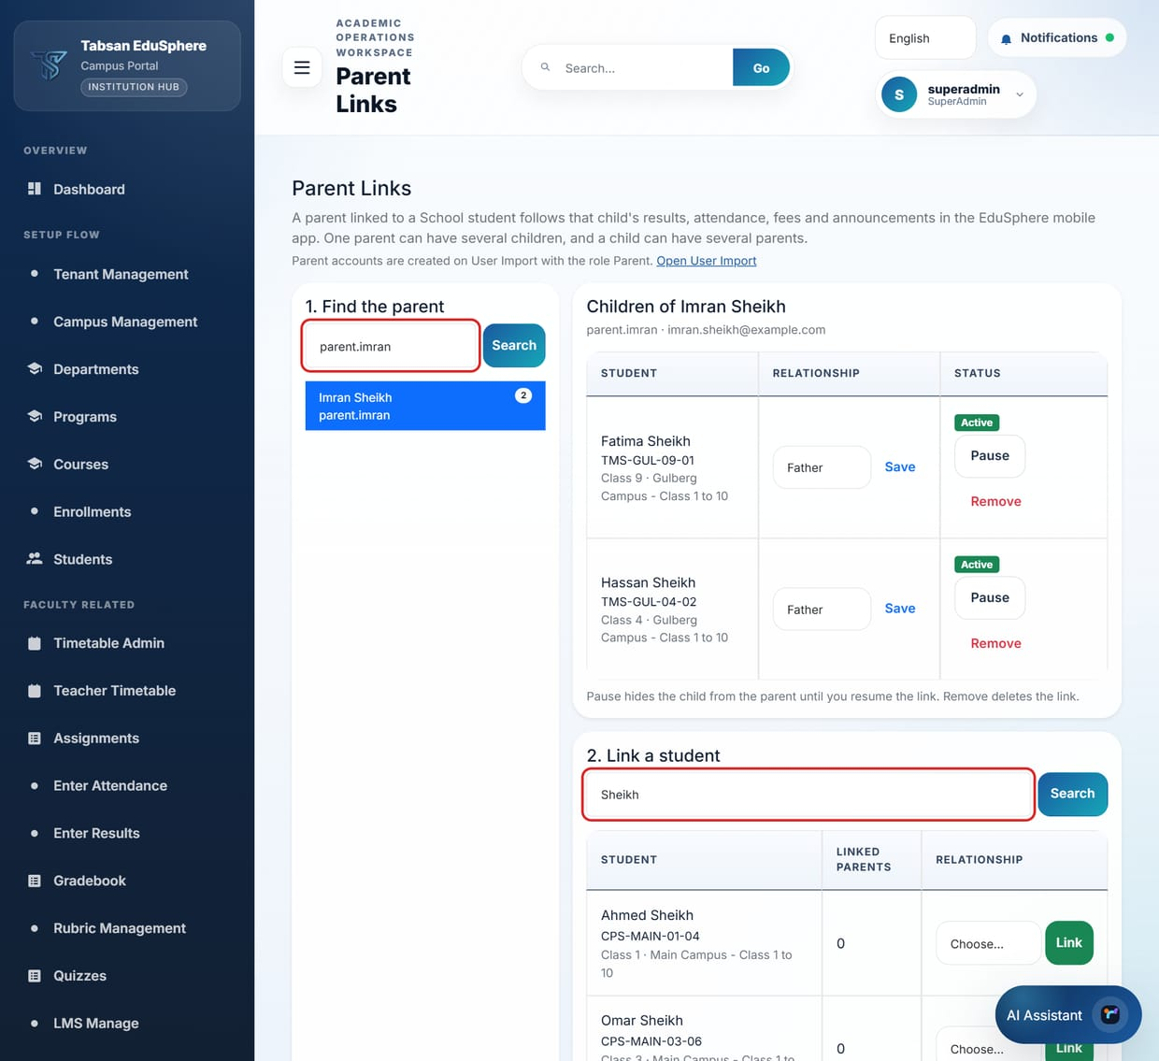
Figure 4.5 Portal › Parent Links: the parent found by name (left), their children, and the student search (both search boxes outlined)
The children appear under Children of … with their class and relationship. The parent sees them in the app the next time its home screen loads (open the app again, or pull the screen down to refresh).
To… | On the parent's row for the child
Correct the relationship | Choose another value and select Save.
Hide a child for a while | Select Pause. The link stays on the list as Paused and the parent no longer sees the child; Resume shows the child again.
End the link | Select Remove and confirm. The parent stops seeing the child at once. Linking the same child again later is allowed.

IMPORTANT Only School students can be linked, and only to accounts with the role Parent (section 4.3). An Admin sees and links only the students of the departments assigned to them, and only the parent accounts of their own school (any campus); a SuperAdmin sees all. If Parent Links is missing from the menu, the installation has no active School department yet, or the menu is switched off for Admins in Sidebar Settings.

TIP A SuperAdmin who creates parent accounts for a school on User Import should first choose that school's Tenant and Campus at the top of the page. Otherwise the parents belong to the default tenant and the school's own Admins cannot find them on Parent Links (the SuperAdmin can still link them).

For integrations
A script (for example a nightly import from the admissions system) can make the same links through the API with an Admin token; the same rules apply.
Request | Purpose
GET /api/v1/parent-portal/parents?search= | Find Parent accounts by username, name, email or phone
GET /api/v1/parent-portal/students?search= | Find School students by registration number or name
GET /api/v1/parent-portal/parents/{parentUserId}/links | A parent's children, with names, classes and relationships
PUT /api/v1/parent-portal/links | Create or update a link (relationship; isActive = false pauses it)
DELETE /api/v1/parent-portal/links/{parentUserId}/{studentProfileId}?remove=true | Remove a link (without remove=true, the link is paused)

4.5 Single sign-on (optional)
Who does this: SuperAdmin
If your institution signs in with Microsoft, Google, OpenID Connect or SAML, set it up in the portal as described in the SSO Setup Guide. The app then shows a Sign in with … button for each provider, under the password fields.
- The user taps Sign in with …. The phone's browser opens the portal's single sign-on page.
- The user signs in with the institution's account, as on a computer.
- The portal hands a one-time code back to the app (edusphere://sso); the app exchanges it with the API for its own session. The code works once and expires after HandoffSeconds.

Single sign-on in the app needs PortalBaseUrl and the same AppRedirectUri on the API, the portal and the app build (sections 2.2, 2.3 and 3.2).

4.6 Push notifications (optional)
Who does this: IT administrator
Without push the app works fully; users see new items in the Notifications tab when they open it. With push, phones show a notification as soon as something happens (new assignment, published result, attendance alert, announcement, live class), following each user's notification choices in the portal.
- Create a Firebase project for the institution. Add an Android app with your app id (and an iOS app with your bundle id, uploading the APNs key in Firebase).
- Build the app with the downloaded google-services.json (-GoogleServicesJson; iOS: -GoogleServiceInfoPlist).
- In Firebase › Project settings › Service accounts, generate a private key. On the API set Mobile:Fcm:Enabled = true and Mobile:Fcm:ServiceAccountFile to the key file (or ServiceAccountJson from a secret store). Never put the key in source control.
- Restart the API. pushEnabled in the configuration (section 2.4) becomes true; phones register after their next sign-in.

5 Install the App and Sign In
This chapter is for everyone who uses the app. It takes about a minute.

5.1 Install
Who does this: Students, teachers and parents
- Android: install the app from Google Play (search for your institution's app name), or open the APK file your institution shared.
- iPhone: install it from the App Store.
- Allow notifications when the app asks, to receive alerts on the phone.

5.2 Sign in
Who does this: Students, teachers and parents
When the app starts it shows the Tabsan emblem while it connects, then the sign-in screen. The name under the logo is your institution's name from the portal.
- Enter your Username: the same as for the web portal.
- Enter your Password: the same as for the web portal.
- Tap Sign in.

  Starting | Sign-in screen | 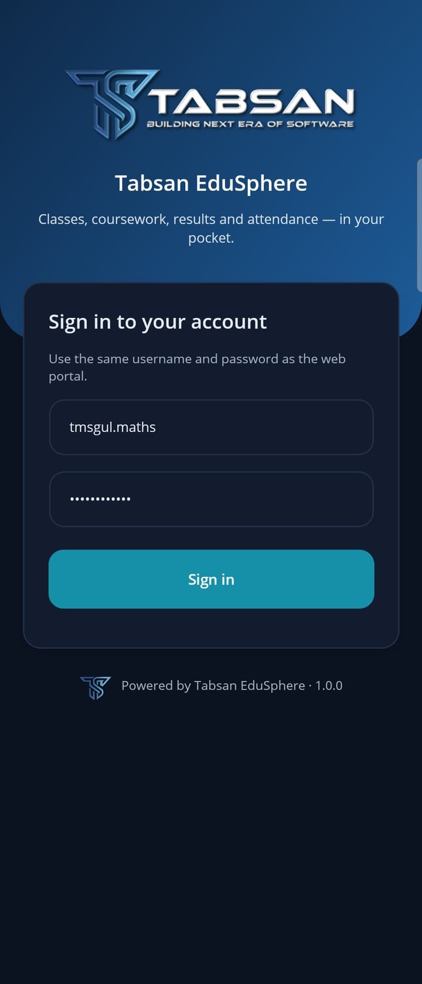  Ready to sign in
Figure 5.1 Starting the app and signing in with the portal account
TIP You stay signed in. Next time the app opens straight on your Home screen until you sign out in Settings or your institution ends the session. If the phone offers to save the password (for example Samsung Pass or Google Password Manager), choose whatever you prefer; the app works either way.

5.3 If the app asks for an authenticator code
Who does this: Users with two-factor authentication
When two-factor authentication is on for your account, an Authenticator code field appears after you tap Sign in. Enter the 6-digit code from your authenticator app and tap Sign in again. It is the same code you use for the portal.

5.4 First sign-in with a temporary password
Who does this: New users created by import (often parents)
Accounts created through User Import start with a temporary password (the username). The first time such an account signs in, the app asks for a new password before it opens. Nothing is saved on the phone until the new password is set.
- Sign in with your username and the temporary password.
- The app shows "Please choose your own password to continue." Enter a New password and type it again in Repeat the new password. It must follow your institution's password rules; the app shows the rule if the password is too weak. If the two differ, the app says "The two new passwords are not the same."
- Tap Sign in. The app signs you in with the new password. Use it for the portal as well.

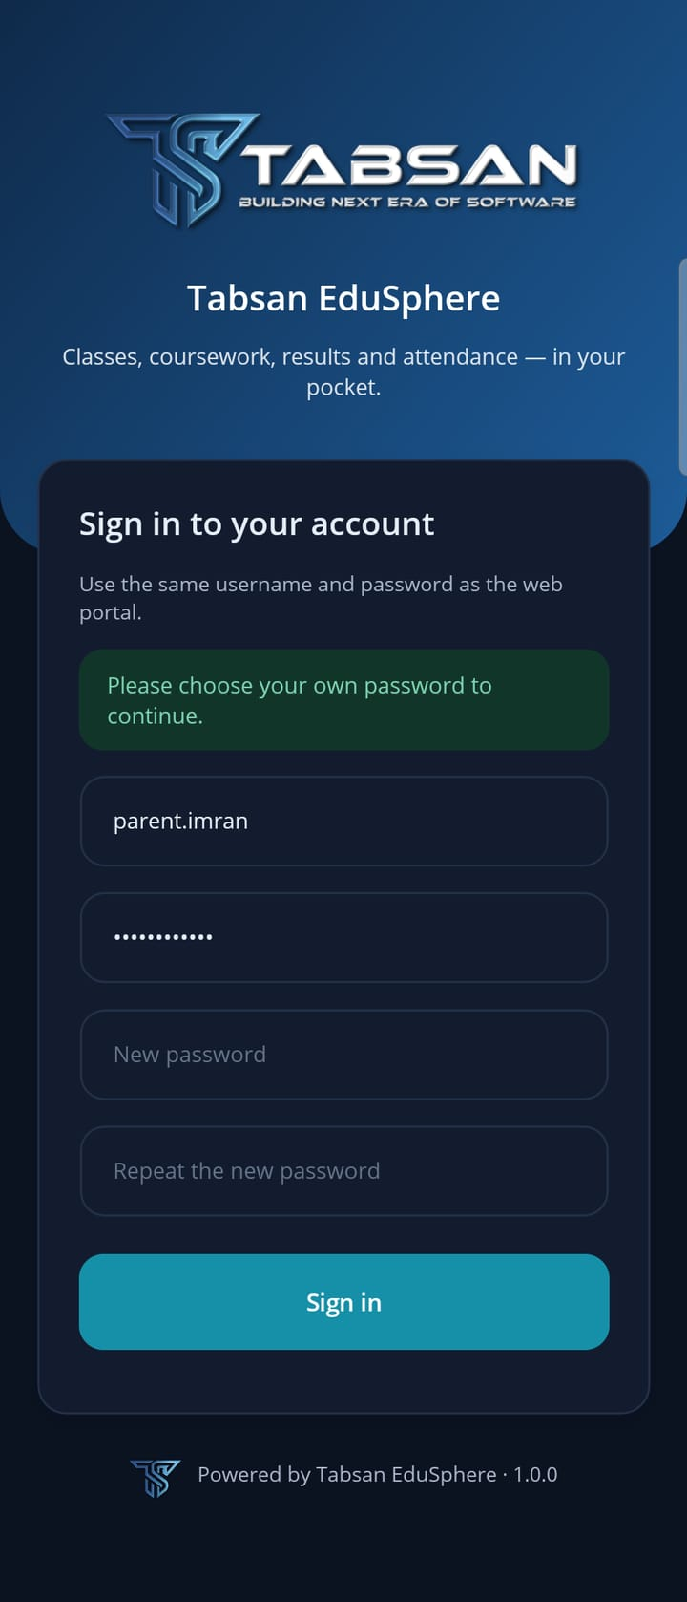  Choose your own password | 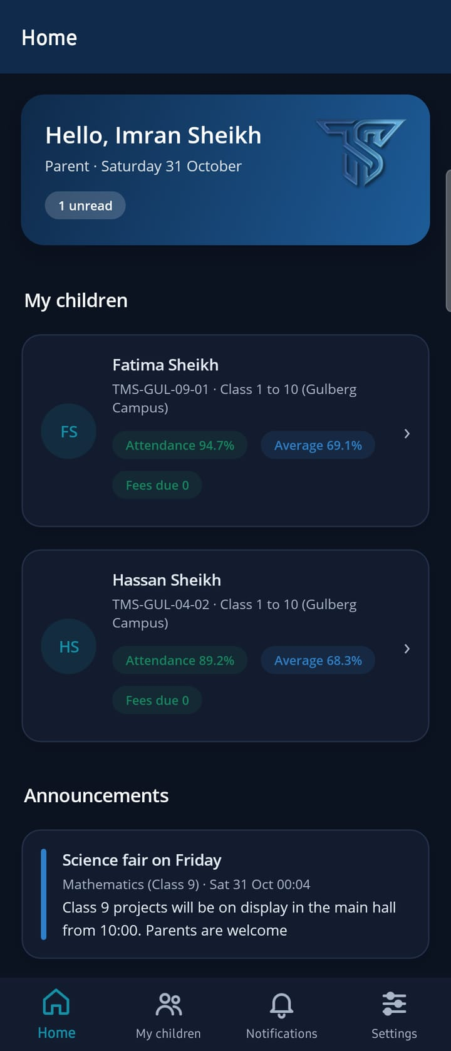  Signed in
Figure 5.2 A parent's first sign-in: the app asks for a new password, then opens the Home screen

5.5 Sign in with your institution's account (SSO)
Who does this: Institutions that use single sign-on
If the sign-in screen shows Sign in with … buttons, your institution uses single sign-on. Tap your institution's button, sign in on the page that opens in the browser, and the app opens again, signed in. If your institution uses only single sign-on, the app says "Your institution uses single sign-on. Use your organization's button below."

5.6 Language, server and signing out
Who does this: Everyone
Open Settings to see your account, change the language, check which server the app is connected to, and sign out. Teachers and parents have a Settings tab; students find Notifications and Settings under More at the end of the tab bar on Android.
- Language: English, اردو (Urdu) or العربية (Arabic). Urdu and Arabic switch the whole app to right-to-left. Course names and messages from the server come in the same language.
- About this app shows the app version and the Server address the app was built for. Give both to your IT team when reporting a problem.
- Sign out removes the session from the phone and stops notifications to it.
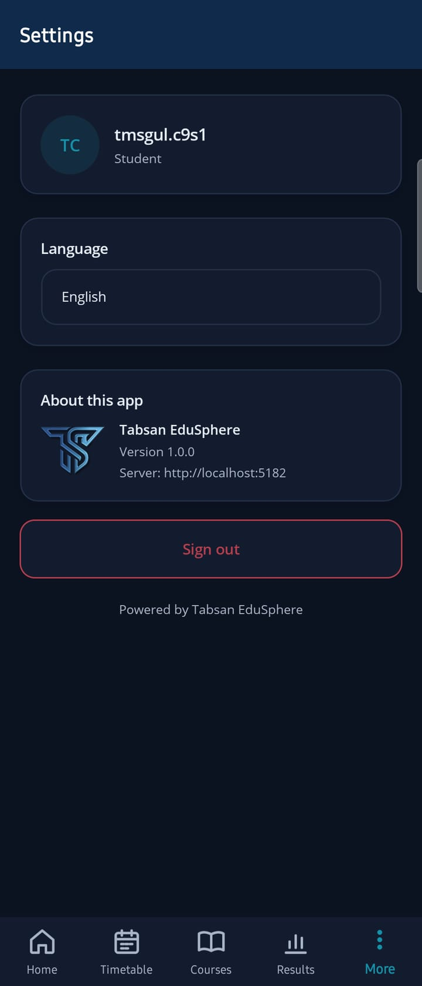  Settings | 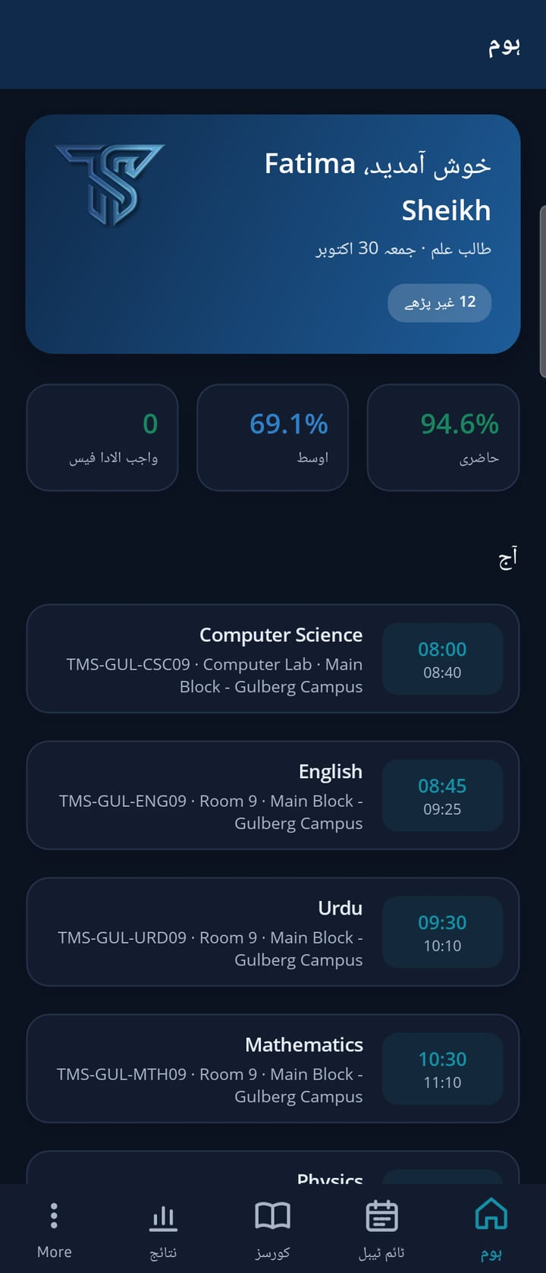  Home in Urdu
Figure 5.3 Settings, and the Home screen after switching to Urdu

6 Using the App — Students
Students have six screens: Home, Timetable, Courses, Results, Notifications and Settings. Android shows five tabs at most, so Notifications and Settings are under More. Pull down on Home or Notifications to refresh.

6.1 Home
Who does this: Students
Home shows the day at a glance: a greeting with the date, unread notifications, your attendance, your average marks (CGPA for University students) and fees due; then today's classes, work that is due, and the latest announcements.
Home | 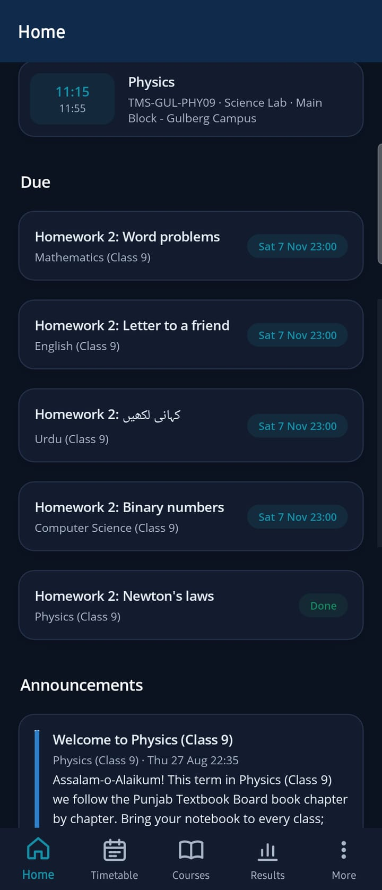  Due work and announcements
Figure 6.1 A Class 9 student's Home screen
- Attendance is green from 75%, amber from 50% and red below.
- Each due item shows its date, or Overdue. Tap it to open the course.
- The figures are the same as in the portal's attendance, results and fee pages.

6.2 Timetable
Who does this: Students and teachers
The week's classes, day by day, with start and end times, subject, course code and room. Today is marked Today.
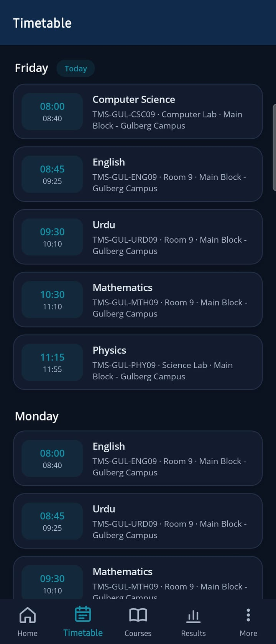
Timetable
Figure 6.2 The weekly timetable

6.3 Courses and course pages
Who does this: Students
The Courses tab lists your courses with their code, class and teacher. Tap a course to see its assignments, materials, quizzes and announcements, and to open its Discussions.
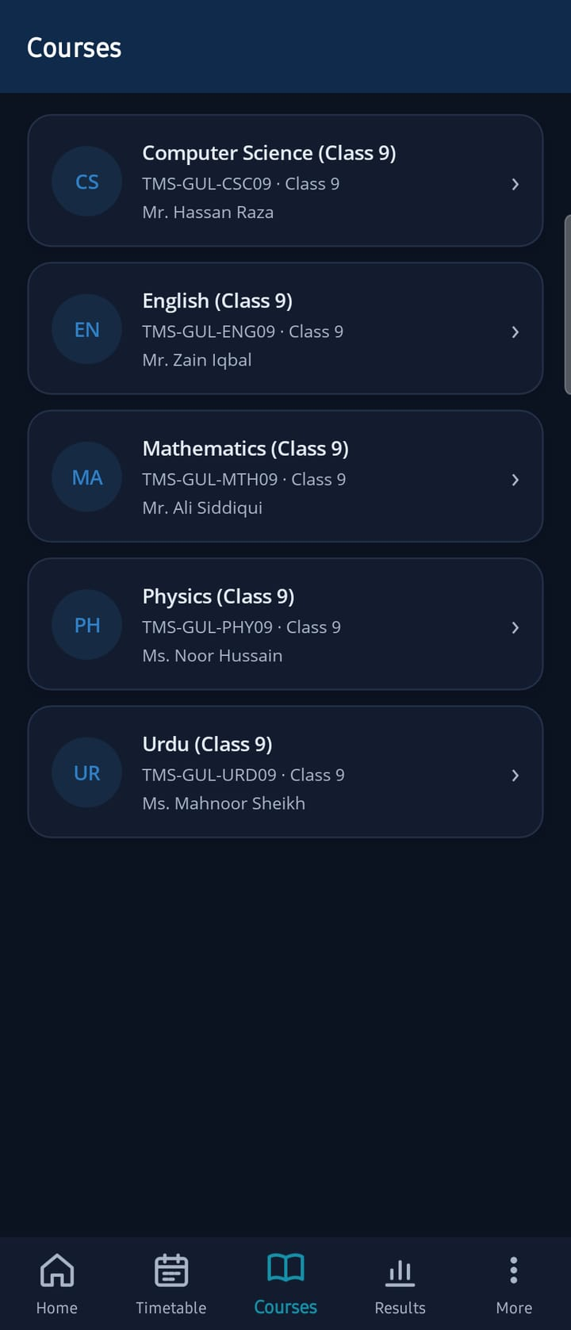  Courses | 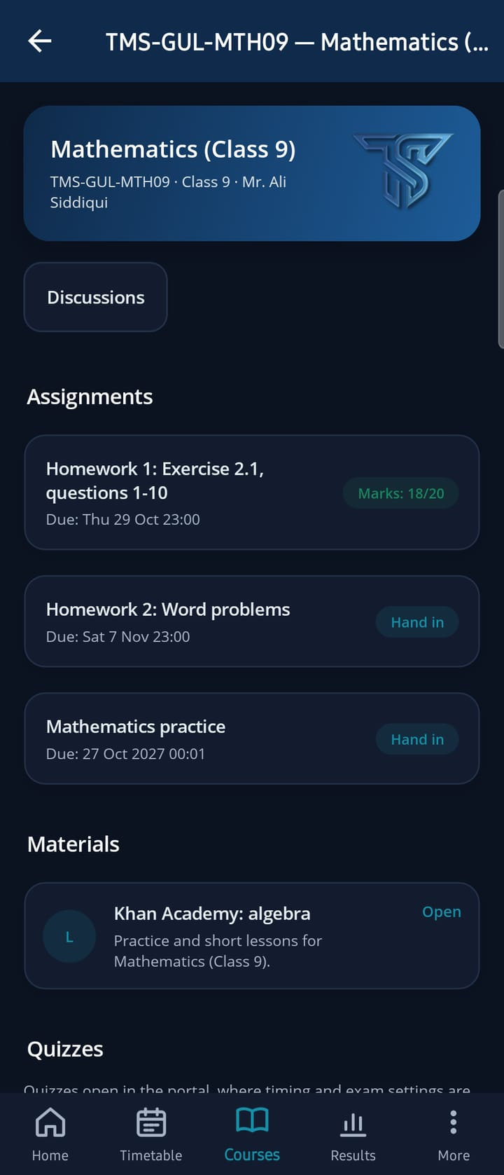  A course
Figure 6.3 Courses and a course page
- Each assignment shows its due date and state: Hand in, Not graded yet (handed in) or your marks.
- Tap a material to open it. Tap a quiz to take it in the portal (the browser opens), where exam timing and settings are kept.

6.4 Hand in an assignment
Who does this: Students
- Open the course and tap the assignment.
- Type your answer, and/or tap Take a photo to photograph written work, or Add a file to attach a document.
- Tap Hand in. The app returns to the course, where the assignment now shows Not graded yet. The teacher sees the submission in the portal and in the app ("1 to grade", section 7.3).

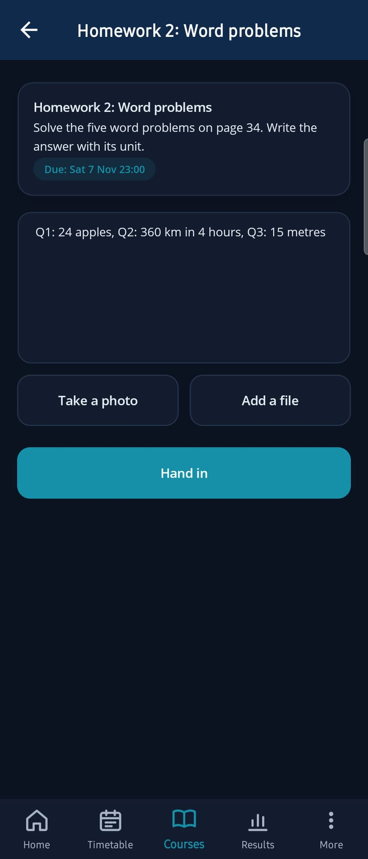
Hand in
Figure 6.4 Handing in an assignment

6.5 Results and attendance
Who does this: Students
The Results tab lists each published result with marks and percentage, attendance per course, and report cards when your institution publishes them.
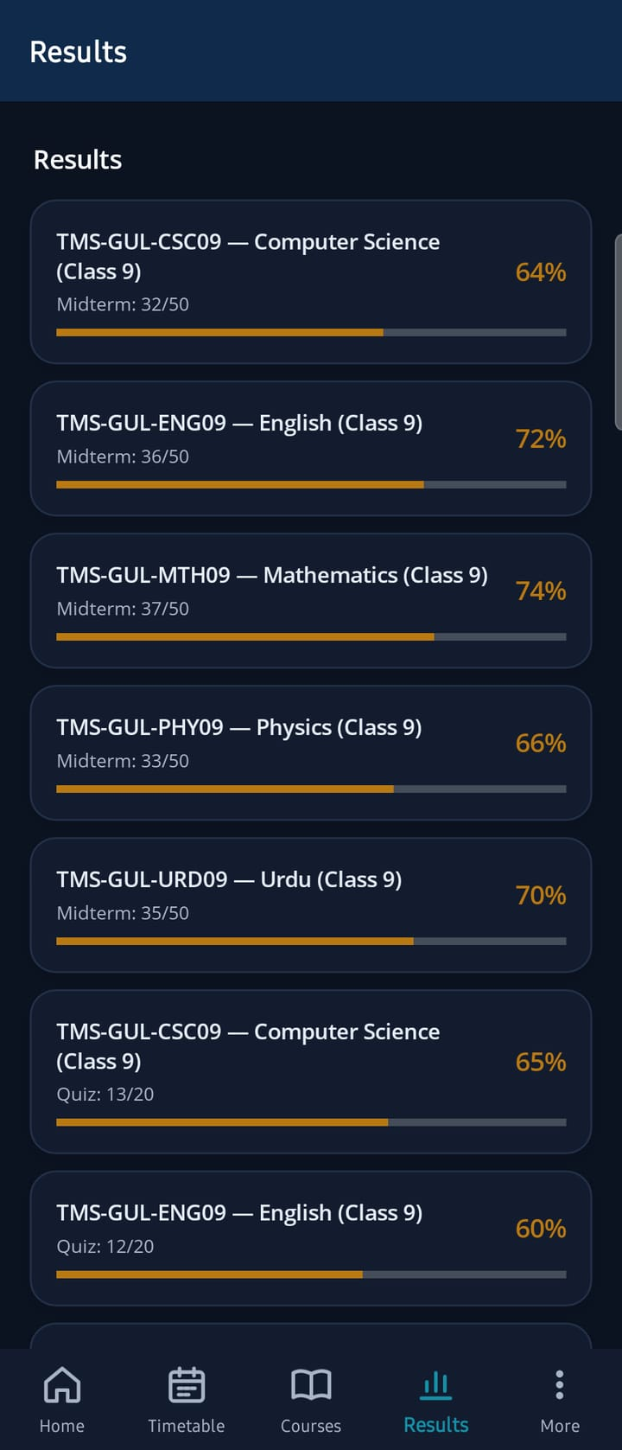  Results | 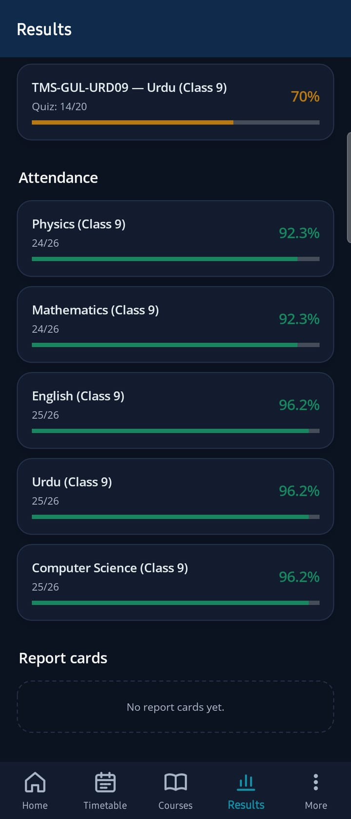  Attendance per course
Figure 6.5 Results and attendance

6.6 Notifications
Who does this: Everyone
The same notifications as the portal's bell: new assignments, results, attendance alerts, announcements and more, with the time each was sent (in the phone's time zone). Unread items have a dot; tap one to mark it read, or use Mark all as read.
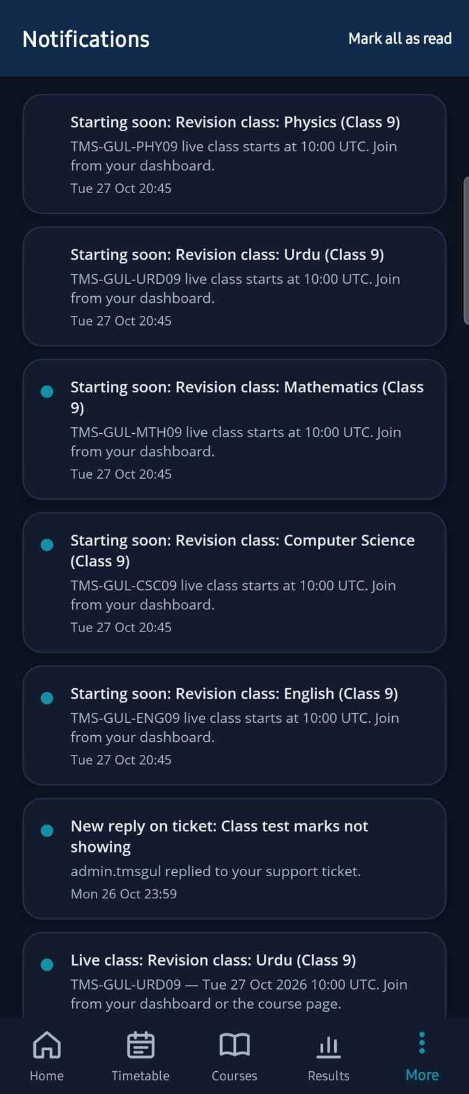
Notifications
Figure 6.6 Notifications

7 Using the App — Teachers
Teachers have Home, Timetable, Courses, Notifications and Settings. The app covers the everyday classroom tasks; the portal remains the place for setting up courses and for the full grading workspace.

7.1 Home
Who does this: Teachers
Your number of courses, the submissions waiting to be graded, today's classes with course codes and rooms, and announcements.
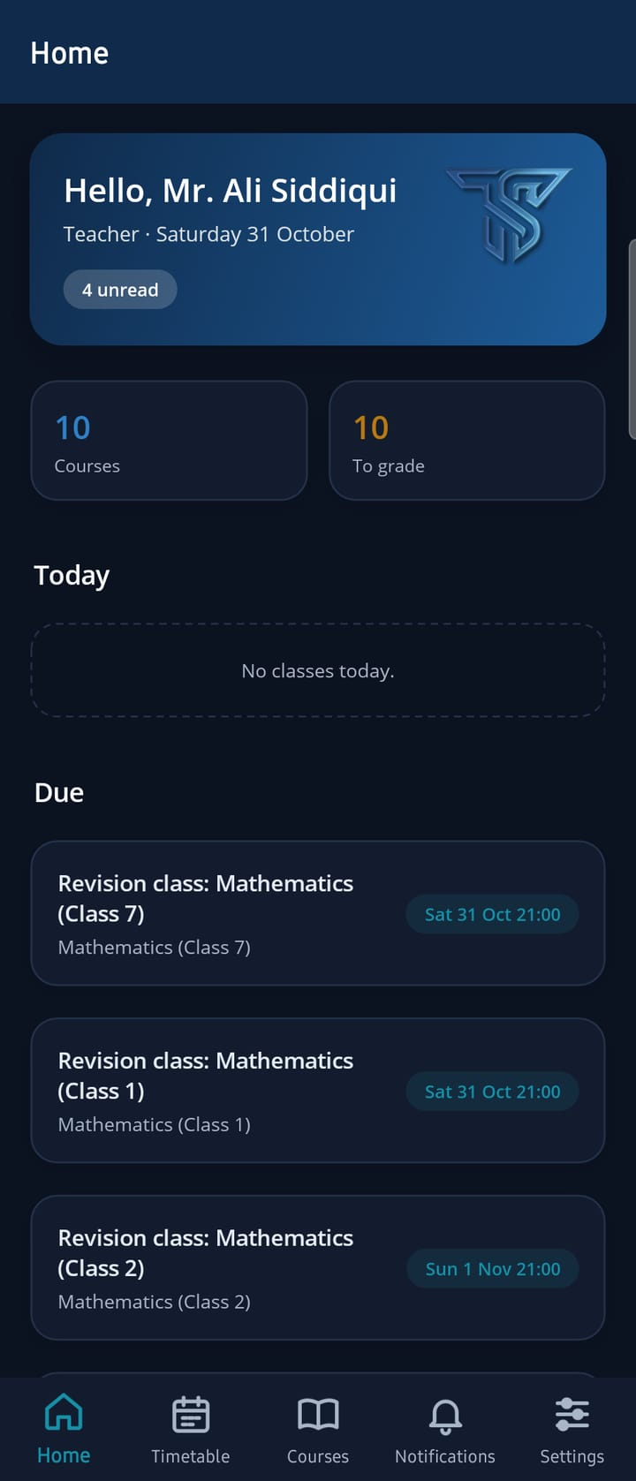  Teacher Home | 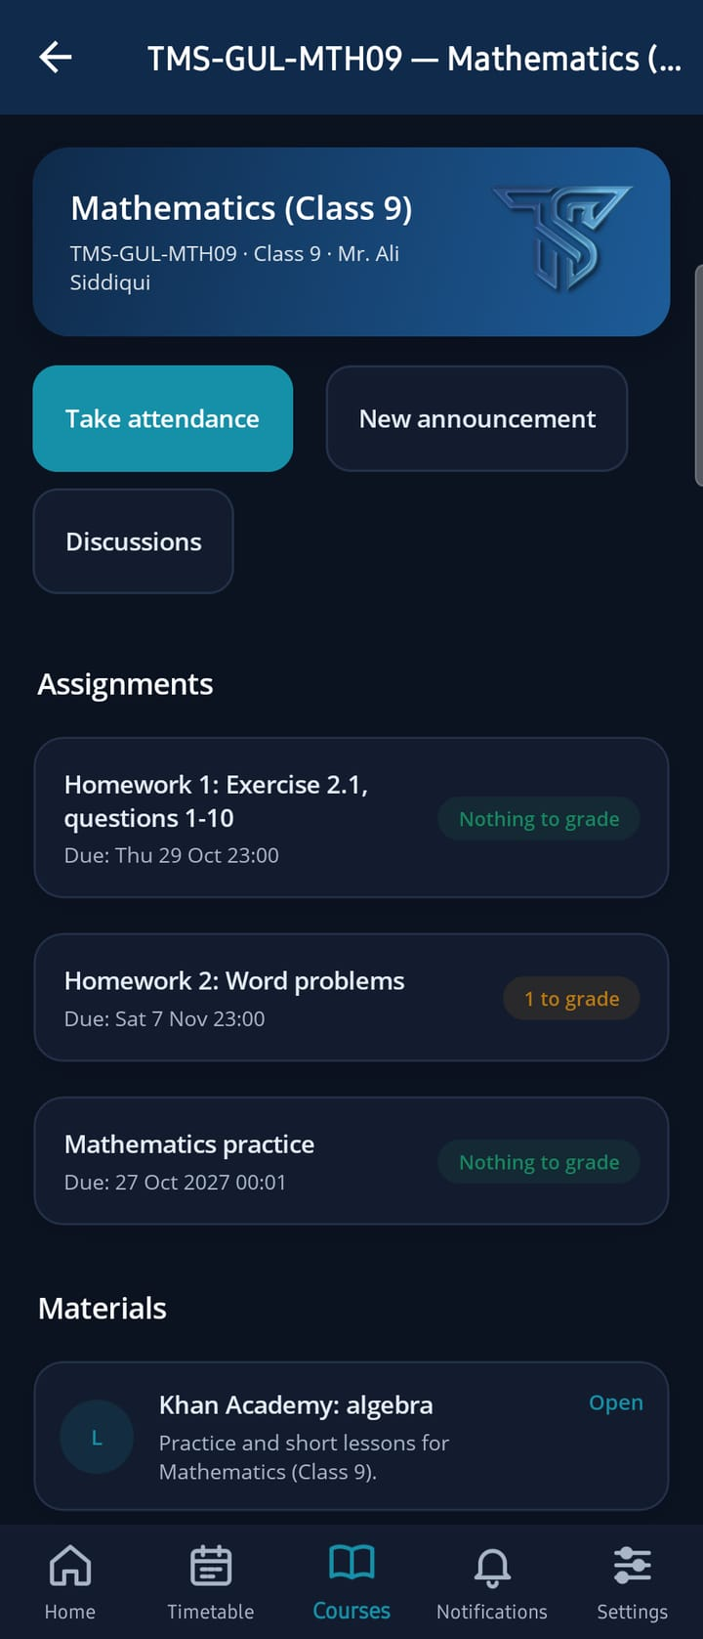  A course
Figure 7.1 A teacher's Home screen and course page

7.2 Take attendance
Who does this: Teachers
- Open the course and tap Take attendance.
- Check the date. Every student starts as Present.
- Tap a student's status to change it: Present → Absent → Late → Excused.
- Tap Save. The app confirms "Attendance saved." The attendance appears in the portal and in the student's and parent's app at once.

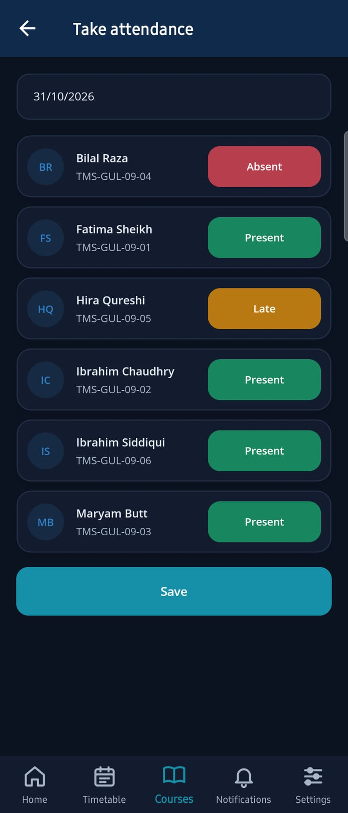  Marking | 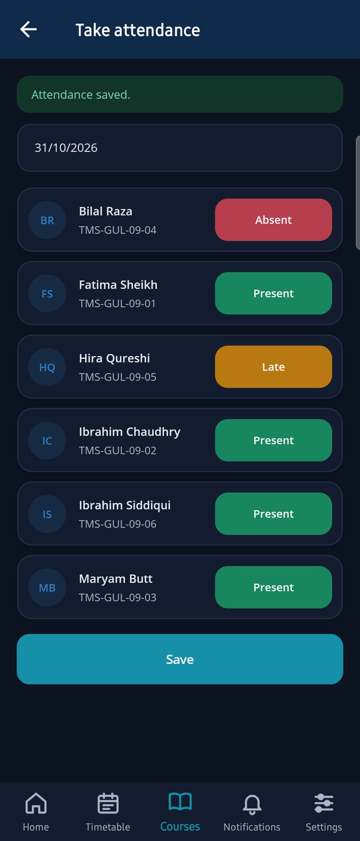  Saved
Figure 7.2 Taking attendance: green present, red absent, amber late, blue excused

7.3 Grade submissions
Who does this: Teachers
Each assignment card on the course page shows how many submissions wait for grading ("1 to grade" or "Nothing to grade"). Tap it to see each student's submission with their typed answer, enter Marks and Feedback, and tap Save grade. The app confirms "Grade saved." and the student's assignment shows the marks. Rubrics, annotations and similarity checks are in the portal's grading workspace.
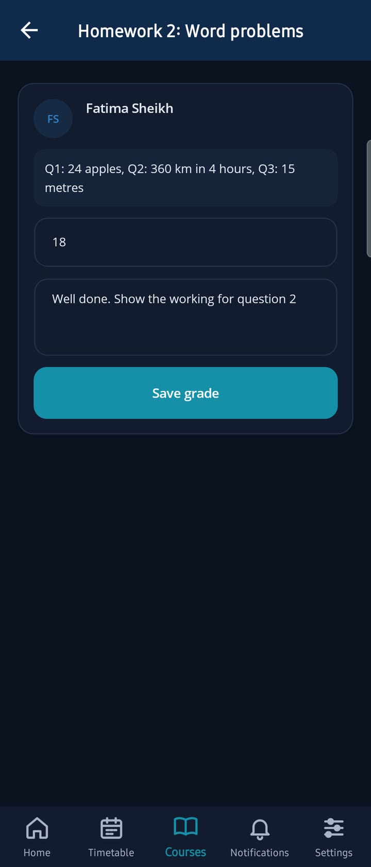
Grading
Figure 7.3 Grading a submission

7.4 Post an announcement
Who does this: Teachers
- Open the course and tap New announcement.
- Enter a Title and the Message.
- Tap Post. The announcement appears on the course in the portal and the app, and students receive a notification.

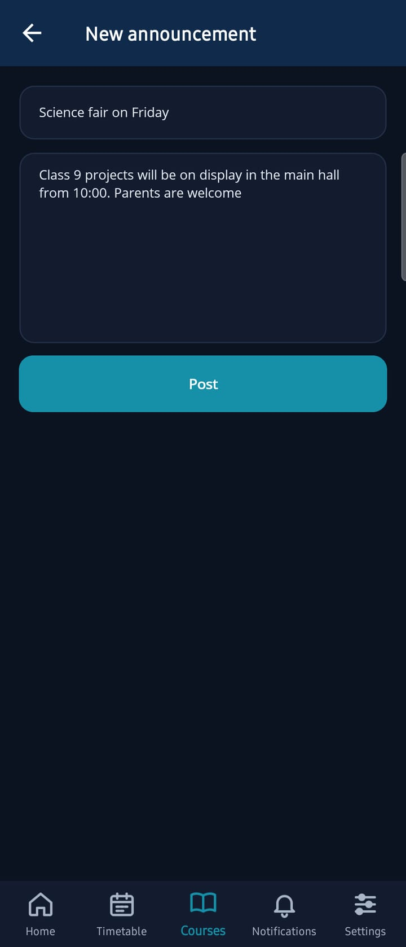  New announcement | 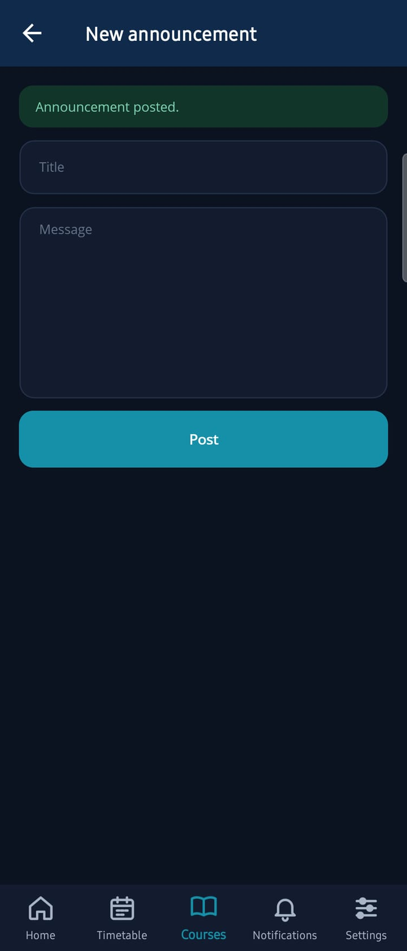  Posted
Figure 7.4 Posting an announcement from the app

8 Using the App — Parents
Parents have Home, My children, Notifications and Settings, and see only the children linked to their account (section 4.4).

8.1 Home
Who does this: Parents
One card per child with attendance, average marks and fees due. Tap a child to see more.
Parent Home | 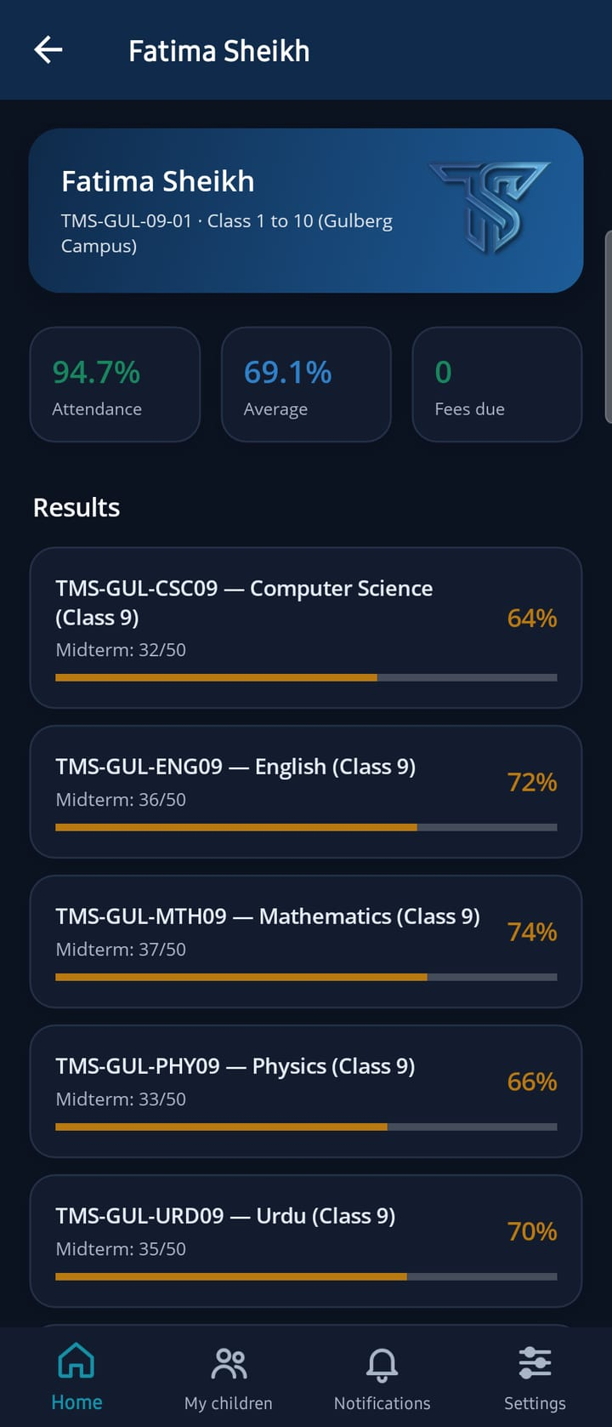  A child
Figure 8.1 A parent's Home screen and a child's page

8.2 A child's page
Who does this: Parents
The child's attendance, average and fees, then published results, attendance per course, report cards and the announcements from the child's courses.
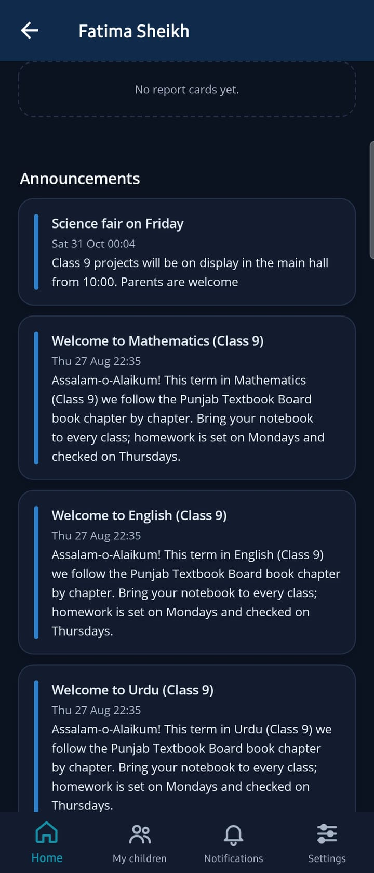
Results and announcements
Figure 8.2 Further down a child's page

9 How the App and the Portal Stay in Step
Because both use the same server, every change is visible in both at once. The table shows where the most common actions appear.

9.1 Where each action shows
Done in the app | Shows in the portal | Shows in other apps
Teacher takes attendance | Attendance pages and reports | Students' and parents' attendance figures
Teacher posts an announcement | Course announcements and the bell | Students' Home, course page and Notifications; parents' child page
Teacher saves a grade | Assignment submissions and gradebook | The student's assignment state and marks
Student hands in work | Assignment submissions and the grading workspace | The teacher's "to grade" count
User chooses a new password at the first sign-in | The portal sign-in uses the new password | —
Done in the portal: results published, timetable changed, fees updated | — | The app shows it the next time the screen loads

9.2 Example: an announcement from the app
For this guide the teacher of Class 9 Mathematics posted "Science fair on Friday" from the phone (section 7.4). Without any further step it appeared at the top of the student's portal inbox, on the student's Home screen in the app, and on the Home screen of Fatima's father, Imran Sheikh. Attendance behaves the same way: the teacher saved attendance from the phone, and the parent's screen shows Fatima's attendance as 94.7%, up from the 94.6% on her own screen captured just before.
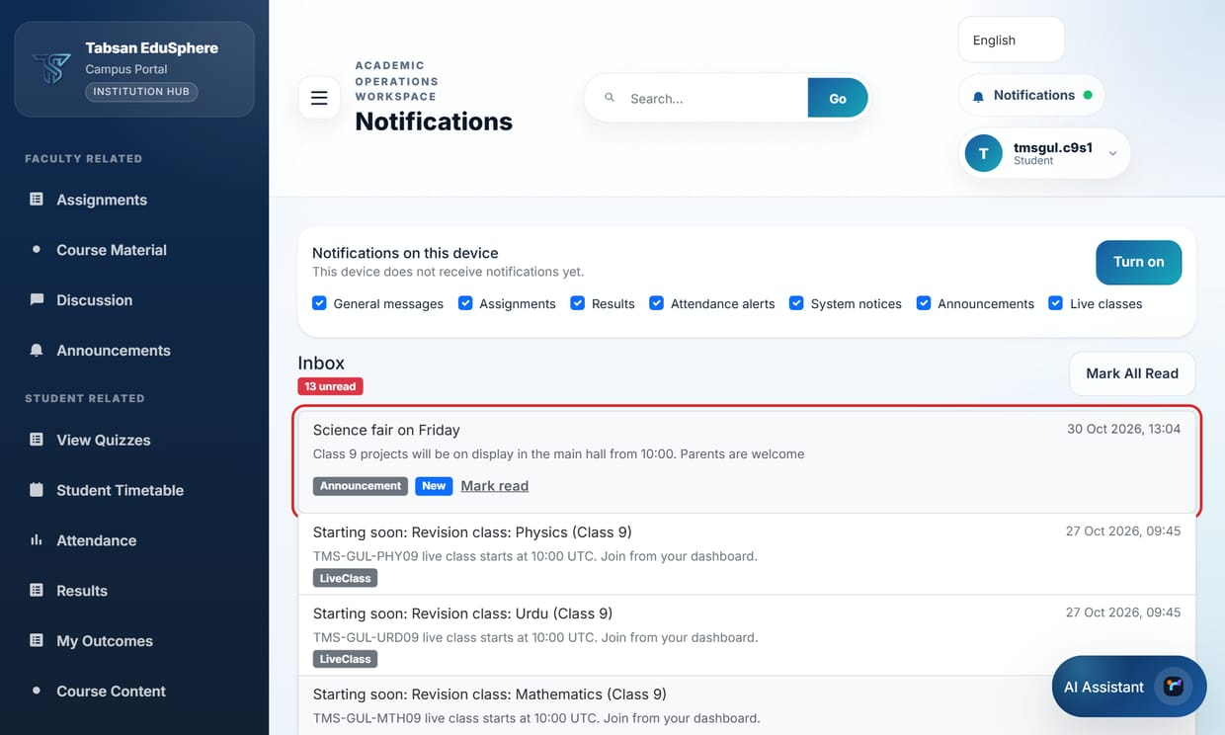
Figure 9.1 The announcement posted from the phone, in the student's portal
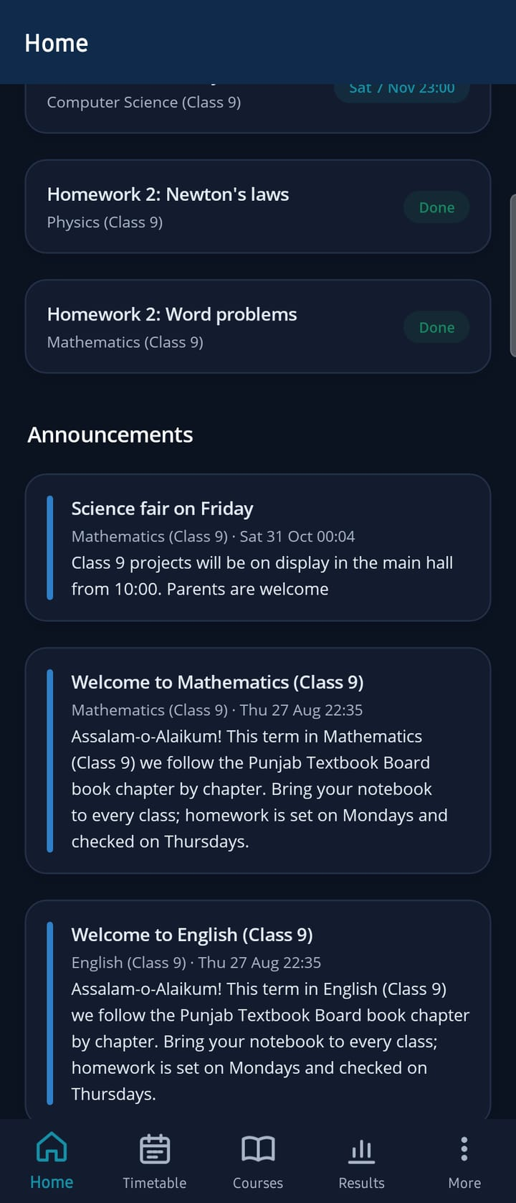  Student app | Parent app
Figure 9.2 The same announcement in the student's app and the parent's app

10 Troubleshooting

10.1 Messages and what to do
The app says | Likely cause | What to do
No connection to EduSphere. Check your internet and try again. | No internet, or the phone cannot reach the API | Try mobile data and Wi-Fi. IT: open …/api/v1/mobile/config from a phone (section 2.4); check DNS, firewall and certificate.
The username or password is not correct. | Wrong details | Use the portal username and password. Reset the password in the portal if needed.
Please choose your own password to continue. | First sign-in with a temporary password | Choose a new password (section 5.4).
The two new passwords are not the same. | Typing mistake | Type the same new password in both fields.
This version of the app is no longer supported. Please update it. | App older than MinimumVersion | Tap Update or update from the store.
Your session has ended. Please sign in again. | The session expired or was ended in the portal | Sign in again.
Your EduSphere account is inactive or locked. Contact your administrator. | Account locked or deactivated | Administrator: unlock or activate the account in the portal.
Single sign-on was cancelled. | The browser was closed before signing in | Tap Sign in with … again.

10.2 Other problems
Problem | Cause | Solution
Single sign-on ends in the browser and does not return to the app | AppRedirectUri differs between API, portal and app build, or PortalBaseUrl is empty | Make all three use <scheme>://sso and set PortalBaseUrl (sections 2.2, 2.3, 3.2).
The sign-in screen shows the wrong institution name | Portal branding | Correct it in Dashboard Settings (section 4.1).
A parent sees no children | No active link (none made, or paused), or the student is not in a School department | Link the parent to each child on Parent Links, or select Resume (section 4.4).
No push notifications | Firebase not set up, notifications blocked on the phone, or the user switched that type off | Check pushEnabled (section 2.4), the phone's notification permission and the user's notification settings in the portal.
A course or result is missing in the app | Not published, or the student is not enrolled | Check the same page in the portal: the app shows exactly what the portal shows.
Quizzes do not open | PortalBaseUrl not set | Set Mobile:PortalBaseUrl (section 2.2).
Times differ between the app and the portal | The app shows times in the phone's time zone; the portal shows them as the server keeps them | Nothing to fix: it is the same moment. If the app's times look wrong, check the phone's date and time settings.
A space appears in the username after a dot ("tmsgul. c9s1") | The keyboard's automatic spacing (seen on Samsung keyboards in builds before this guide) | Install the current build, which turns keyboard suggestions off in the username field, or delete the space before tapping Sign in.
"Update" button does nothing | Store URL not set | Fill in AndroidStoreUrl / IosStoreUrl.

TIP When reporting a problem, include the app version and the server address from Settings › About this app, the exact message, and the time it happened. The API also receives crash reports from the app automatically (app version, phone model, the error and the user id; no other personal data).

Appendix A Settings Reference

API (appsettings.json)
Setting | Default | Purpose
Mobile:MinimumVersion | 1.0.0 | Oldest app version allowed
Mobile:LatestVersion | 1.0.0 | Newest published version
Mobile:AndroidStoreUrl / IosStoreUrl | empty | Update button targets
Mobile:PortalBaseUrl | empty | Portal address for single sign-on and quizzes
Mobile:AppRedirectUri | edusphere://sso | Single sign-on return address
Mobile:HandoffSeconds | 120 | Life of the single sign-on code (30–600)
Mobile:MaxConsecutiveFailures | 5 | Failed pushes before a phone is switched off
Mobile:Fcm:Enabled / ProjectId / ServiceAccountFile / ServiceAccountJson | off | Push notifications through Firebase

Portal (appsettings.json)
Setting | Purpose
EduApi:BaseUrl | The API the portal uses (the same API as the app)
Mobile:AppRedirectUri | Where the portal returns single sign-on to the app; same value as on the API

App build (build-whitelabel.ps1)
Parameter | Purpose
-AppName, -AppId | Name and store id
-ApiBaseUrl | The API address built into the app (HTTPS)
-Color, -Scheme | Brand colour; single sign-on address scheme
-Version, -Build | Version shown to users; store build number
-Platform, -Apk | Android or iOS; APK instead of a Google Play bundle
-GoogleServicesJson, -GoogleServiceInfoPlist | Firebase files for push
-KeyStore, -KeyAlias | Google Play upload key (passwords from environment variables)

Appendix B API Endpoints Used by the App
For IT staff checking firewalls, proxies and logs. All are under https://<your API>.
Endpoint | Used for
GET /api/v1/mobile/config | Institution name, versions, languages, sign-in options (before sign-in)
POST /api/v1/auth/login, /auth/refresh, /auth/logout | Password sign-in, keeping the session, signing out
POST /api/v1/auth/force-change-password | Choosing a password at the first sign-in
POST /api/v1/mobile/handoff/redeem | Finishing single sign-on (one-time code)
GET /api/v1/mobile/home, /timetable, /courses, /courses/{id} | Home, Timetable, Courses and course pages
GET /api/v1/mobile/results, /attendance, /report-cards, /announcements, /children | Results, attendance, report cards, parents' screens
/api/v1/assignment/…, /api/v1/attendance/…, /api/v1/discussion/… | Hand-in, grading, taking attendance, discussions
/api/v1/notification/… | Notifications and Mark all as read
POST /api/v1/mobile/devices, /devices/unregister | Push notification registration
POST /api/v1/mobile/crash-reports | Automatic crash reports

Appendix C Glossary
Term | Meaning
API | The EduSphere server program that the portal and the app both use. It holds the business rules and talks to the database.
APK / AAB | Android app files: an APK installs directly; an AAB is uploaded to Google Play.
Firebase Cloud Messaging (FCM) | Google's service that delivers push notifications to Android phones and, through Apple, to iPhones.
Hand-off code | A one-time code with which the portal passes a single sign-on to the app.
HTTPS | Encrypted web connection; required between the app and the API.
Scheme | The start of an app address (for example edusphere://) that the phone sends to the app.
Single sign-on (SSO) | Signing in with the institution's own account (Microsoft, Google, OpenID Connect or SAML).
Two-factor authentication (2FA) | A second sign-in step with a 6-digit code from an authenticator app.
White-label build | The app built with an institution's own name, logo, colour and server address.

Document history
Version | Date | Changes
1.0 | 30 October 2026 | First edition, for app version 1.0.0 with the Tabsan look (logo, colours and redesigned screens).

